**Operating Systems – Lab 08**

**Name:** Hafsa Salman

**Roll no.** 22K-5161

Code Workout 02

**Part A**

Code:

#include<stdio.h>

#include<pthread.h>

static volatile int counter = 0;

void *mythread(void *arg)

{

printf("%s: Begin\n", (char *)arg);

int i;

//int counter = 0;

for (i=0; i<1e7; i++)

{

counter = counter + 1;

}

printf("%s: Done. Counter = %d\n", (char *)arg, counter);

return NULL;

}

int main (int argc, char *argv[])

{

pthread_t p1, p2;

printf("Main: Begin (Counter = %d)\n", counter);

pthread_create(&p1, NULL, mythread, "A");

pthread_create(&p2, NULL, mythread, "B");

pthread_join(p1, NULL);

pthread_join(p2, NULL);

printf("Main: Done with both (Counter = %d)\n", counter);

return 0;

}

Output:

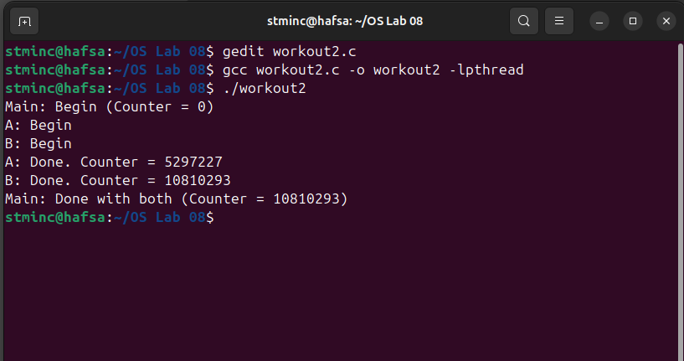

**Part B**

Both threads show different values for counter because they share the same global variable counter.

**Part C**

Code:

#include<stdio.h>

#include<pthread.h>

static volatile int counter = 0;

void *mythread(void *arg)

{

printf("%s: Begin\n", (char *)arg);

int i;

int counter = 0;

for (i=0; i<1e7; i++)

{

counter = counter + 1;

}

printf("%s: Done. Counter = %d\n", (char *)arg, counter);

return NULL;

}

int main (int argc, char *argv[])

{

pthread_t p1, p2;

printf("Main: Begin (Counter = %d)\n", counter);

pthread_create(&p1, NULL, mythread, "A");

pthread_create(&p2, NULL, mythread, "B");

pthread_join(p1, NULL);

pthread_join(p2, NULL);

printf("Main: Done with both (Counter = %d)\n", counter);

return 0;

}

Output:

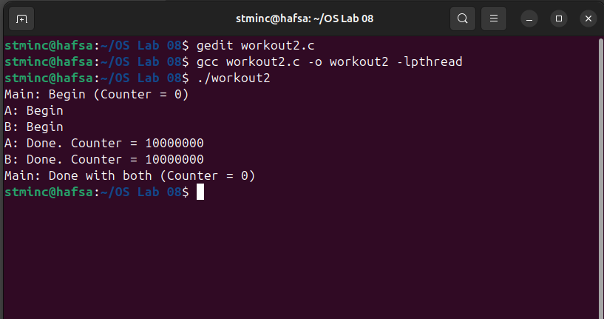

Explanation:

The counter in this code is being used as a local variable. Each thread gets their own local variable resulting in the same answer.

In-Lab Questions

**Question no. 01: Part A**

Code:

#include <stdio.h>

#include <stdlib.h>

#include <time.h>

#define N 10000000

int main()

{

float *A = malloc(N * sizeof(float));

float *B = malloc(N * sizeof(float));

float *C = malloc(N * sizeof(float));

if (A == NULL || B == NULL || C == NULL)

{

fprintf(stderr, "Memory allocation failed\n");

return 1;

}

for (int i = 0; i < N; i++)

{

A[i] = i * 0.5f;

B[i] = i * 0.2f;

}

clock_t start = clock();

for (int i = 0; i < N; i++)

{

C[i] = A[i] + B[i];

}

clock_t end = clock();

double time_taken = (double)(end - start) / CLOCKS_PER_SEC;

printf("C = A + B for %d elements.\n", N);

printf("Time taken: %.3f seconds\n", time_taken);

printf("Verification (first 5 values):\n");

for (int i = 0; i < 5; i++)

{

printf("A[%d] + B[%d] = %.2f + %.2f = %.2f\n", i, i, A[i], B[i], C[i]);

}

free(A);

free(B);

free(C);

return 0;

}

Output:

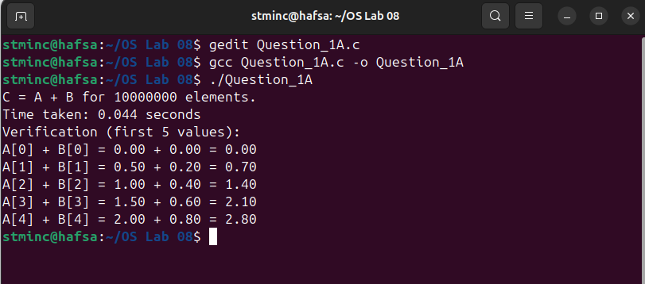

**Question no. 01: Part B**

Code:

#include <stdio.h>

#include <stdlib.h>

#include <pthread.h>

#include <time.h>

#define N 10000000

#define THREADS 10

float *A, *B, *C;

typedef struct

{

int start;

int end;

} ThreadData;

void* add_arrays(void* arg)

{

ThreadData* data = (ThreadData*) arg;

for (int i = data->start; i < data->end; i++)

{

C[i] = A[i] + B[i];

}

pthread_exit(0);

}

int main()

{

pthread_t threads[THREADS];

ThreadData thread_data[THREADS];

A = malloc(N * sizeof(float));

B = malloc(N * sizeof(float));

C = malloc(N * sizeof(float));

if (A == NULL || B == NULL || C == NULL)

{

fprintf(stderr, "Memory allocation failed\n");

return 1;

}

for (int i = 0; i < N; i++)

{

A[i] = i * 0.5f;

B[i] = i * 0.2f;

}

clock_t start = clock();

int chunk_size = N / THREADS;

for (int i = 0; i < THREADS; i++)

{

thread_data[i].start = i * chunk_size;

thread_data[i].end = (i == THREADS - 1) ? N : (i + 1) * chunk_size;

pthread_create(&threads[i], NULL, add_arrays, &thread_data[i]);

}

for (int i = 0; i < THREADS; i++)

{

pthread_join(threads[i], NULL);

}

clock_t end = clock();

double time_taken = (double)(end - start) / CLOCKS_PER_SEC;

printf("Computed C = A + B for %d elements using %d threads.\n", N, THREADS);

printf("Time taken: %.3f seconds\n", time_taken);

printf("Verification (first 5 values):\n");

for (int i = 0; i < 5; i++)

{

printf("A[%d] + B[%d] = %.2f + %.2f = %.2f\n", i, i, A[i], B[i], C[i]);

}

free(A);

free(B);

free(C);

return 0;

}

Output:

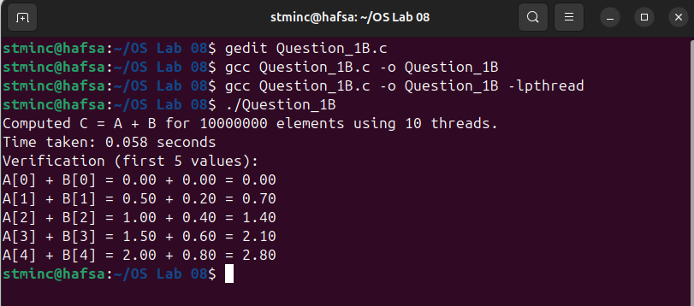

**Question no. 02**

Code:

#include <stdio.h>

#include <stdlib.h>

#include <pthread.h>

typedef struct

{

int *numbers;

int count;

}

ThreadData;

double average;

int minimum;

int maximum;

void* calc_average(void* param)

{

ThreadData* data = (ThreadData*) param;

int sum = 0;

for (int i = 0; i < data->count; i++)

{

sum += data->numbers[i];

}

average = (double) sum / data->count;

pthread_exit(0);

}

void* calc_minimum(void* param)

{

ThreadData* data = (ThreadData*) param;

minimum = data->numbers[0];

for (int i = 1; i < data->count; i++)

{

if (data->numbers[i] < minimum)

{

minimum = data->numbers[i];

}

}

pthread_exit(0);

}

void* calc_maximum(void* param)

{

ThreadData* data = (ThreadData*) param;

maximum = data->numbers[0];

for (int i = 1; i < data->count; i++)

{

if (data->numbers[i] > maximum)

{

maximum = data->numbers[i];

}

}

pthread_exit(0);

}

int main(int argc, char* argv[])

{

if (argc < 2)

{

fprintf(stderr, "Usage: %s <list of integers>\n", argv[0]);

return 1;

}

int count = argc - 1;

int *numbers = malloc(count * sizeof(int));

for (int i = 0; i < count; i++)

{

numbers[i] = atoi(argv[i + 1]);

}

ThreadData data = { numbers, count };

pthread_t tid_avg, tid_min, tid_max;

pthread_create(&tid_avg, NULL, calc_average, &data);

pthread_create(&tid_min, NULL, calc_minimum, &data);

pthread_create(&tid_max, NULL, calc_maximum, &data);

pthread_join(tid_avg, NULL);

pthread_join(tid_min, NULL);

pthread_join(tid_max, NULL);

printf("The average value is %.0f.\n", average);

printf("The minimum value is %d.\n", minimum);

printf("The maximum value is %d.\n", maximum);

free(numbers);

return 0;

}

Output:

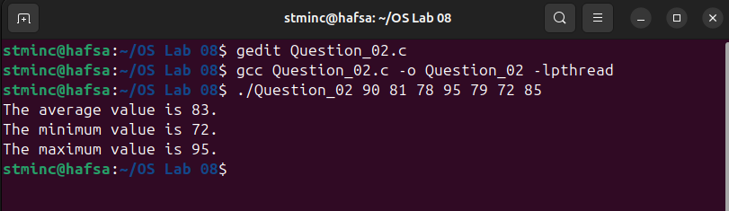

Lab Exercises

**Task no. 01**

Code:

#include<stdio.h>

#include<stdlib.h>

#include<pthread.h>

void* thread_func (void* arg)

{

int num = *(int*)arg;

printf("Thread %d started\n", num);

pthread_exit((void*)(long)num);

}

int main()

{

pthread_t threads[3];

int thread_num[3] = {1, 2, 3};

void* retval;

for (int i=0; i<3; i++)

{

int status = pthread_create(&threads[i], NULL, thread_func, &thread_num[i]);

if (status != 0)

{

printf("Error creating thread %d\n", thread_num[i]);

}

else

{

pthread_join(threads[i], &retval);

printf("Thread %d terminated with return value %ld\n", thread_num[i], (long)retval);

}

}

return 0;

}

Output:

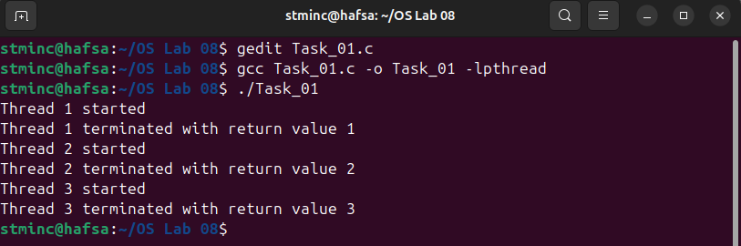

**Task no. 02**

Code:

#include<stdio.h>

#include<pthread.h>

void* table(void* arg)

{

int n = *(int*)arg;

for (int i=1; i*n<=1000; i++)

{

printf("%d x %d = %d\n", n, i, n*i);

}

pthread_exit(0);

}

int main()

{

pthread_t t[4];

int nums[4] = {5, 6, 7, 8};

for (int i=0; i<4; i++)

{

pthread_create(&t[i], NULL, table, &nums[i]);

}

for (int i=0; i<4; i++)

{

pthread_join(t[i], NULL);

}

return 0;

}

Output:

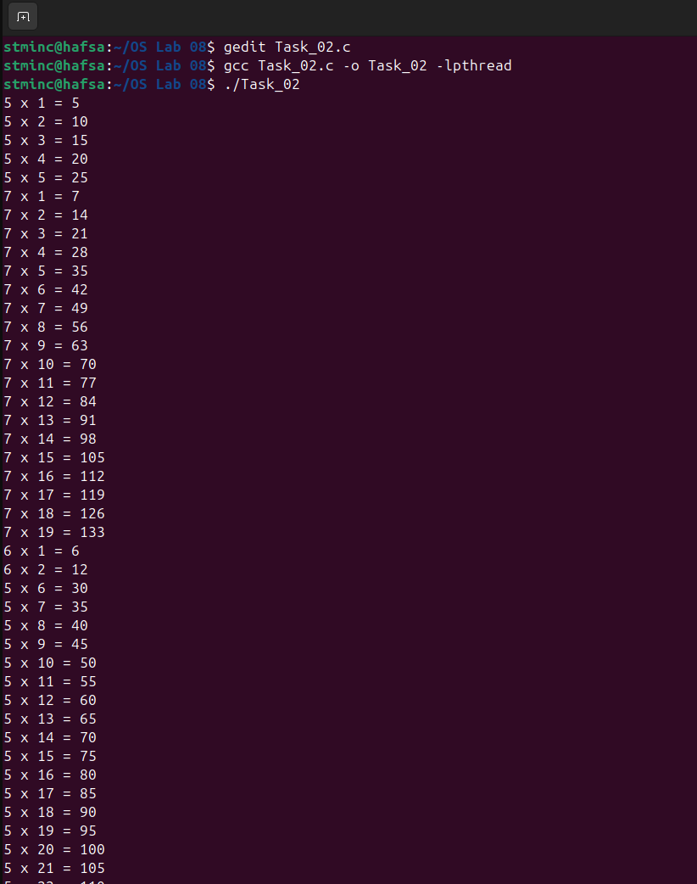

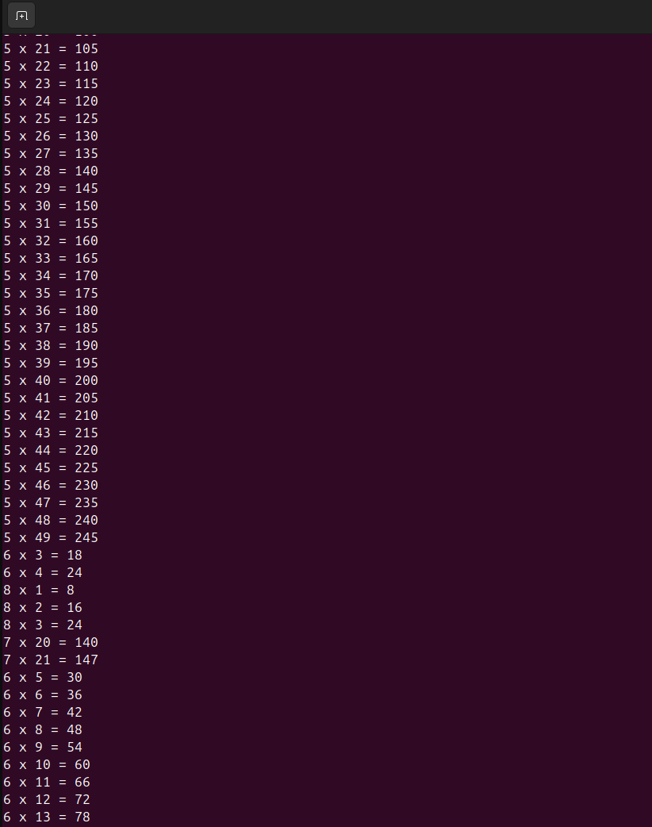

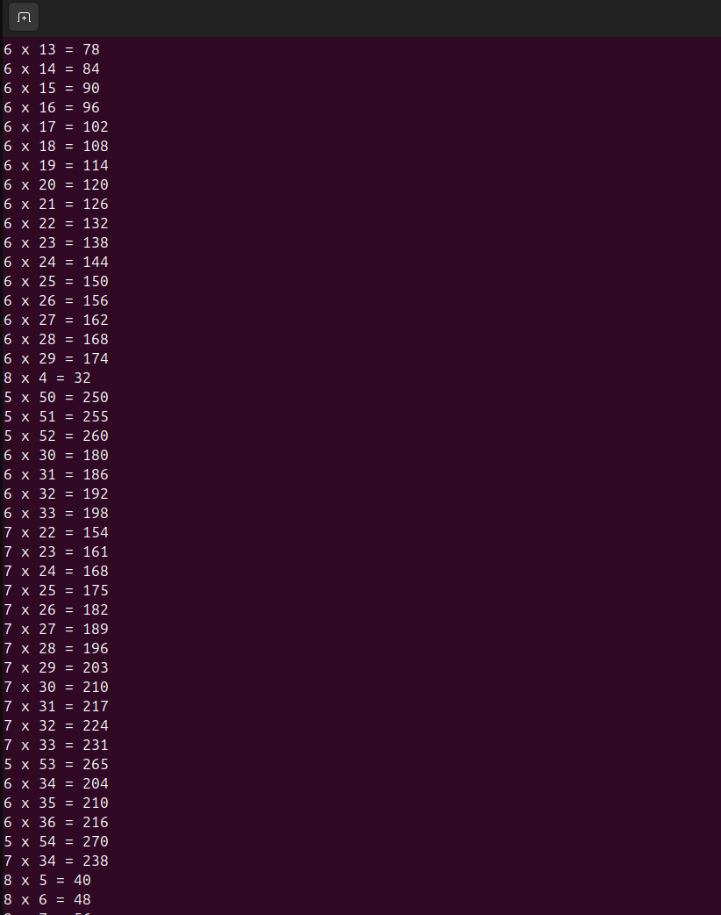

The output is very long, but it is fulfilling the task requirement.

**Task no. 03**

Code:

#include<stdio.h>

#include<stdlib.h>

#include<pthread.h>

#include<unistd.h>

void* thread_func(void* arg)

{

int tid = *(int*)arg;

printf("Hello from thread %d\n", tid);

pthread_exit(0);

}

int main(int argc, char* argv[])

{

if (argc != 2)

{

printf("Usage: %s <number_of_threads>\n", argv[0]);

return 1;

}

int N = atoi(argv[1]);

pthread_t threads[N];

int thread_ids[N];

for (int i=0; i<N; i++)

{

thread_ids[i] = i+1;

pthread_create(&threads[i], NULL, thread_func, &thread_ids[i]);

if ((i+1)%4 == 0)

{

sleep(1);

}

}

for (int i=0; i<N; i++)

{

pthread_join(threads[i], NULL);

}

return 0;

}

Output:

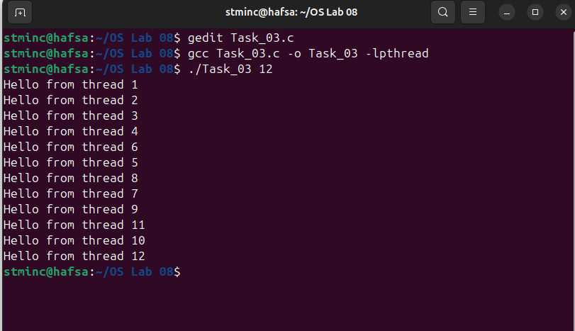

**Task no. 04**

Code:

#include<stdio.h>

#include<pthread.h>

int arr[10] = {1, 2, 3, 4, 5, 6, 7, 8, 9, 10};

int sum_1 = 0, sum_2 = 0;

void* sum_half_1 (void* arg)

{

for (int i=0; i<5; i++)

{

sum_1 += arr[i];

}

pthread_exit(0);

}

void* sum_half_2 (void* arg)

{

for (int i=5; i<10; i++)

{

sum_2 += arr[i];

}

pthread_exit(0);

}

int main()

{

pthread_t t1, t2;

pthread_create(&t1, NULL, sum_half_1, NULL);

pthread_create(&t2, NULL, sum_half_2, NULL);

pthread_join(t1, NULL);

pthread_join(t2, NULL);

int total = sum_1 + sum_2;

printf("Total Sum: %d\n", total);

return 0;

}

Output:

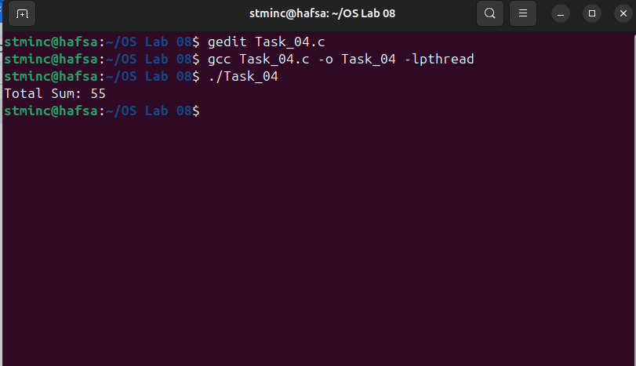

**Task no. 05**

Code:

#include <stdio.h>

#include <pthread.h>

#include <unistd.h>

#define NUM_PARTICIPANTS 10

pthread_mutex_t reg_mutex = PTHREAD_MUTEX_INITIALIZER;

pthread_mutex_t ann_mutex = PTHREAD_MUTEX_INITIALIZER;

pthread_mutex_t sponsor_mutex = PTHREAD_MUTEX_INITIALIZER;

pthread_mutex_t query_mutex = PTHREAD_MUTEX_INITIALIZER;

void registration(int id)

{

pthread_mutex_lock(&reg_mutex);

printf("Participant %d is being registered by Volunteer 1.\n", id);

sleep(1);

pthread_mutex_unlock(&reg_mutex);

}

void announcements(int id)

{

pthread_mutex_lock(&ann_mutex);

printf("Participant %d receives announcements from Volunteer 2.\n", id);

sleep(1);

pthread_mutex_unlock(&ann_mutex);

}

void sponsors(int id)

{

pthread_mutex_lock(&sponsor_mutex);

printf("Participant %d talks to sponsors (Volunteer 3).\n", id);

sleep(1);

pthread_mutex_unlock(&sponsor_mutex);

}

void queries(int id)

{

pthread_mutex_lock(&query_mutex);

printf("Participant %d has queries resolved by Volunteer 4.\n", id);

sleep(1);

pthread_mutex_unlock(&query_mutex);

}

void* participant(void* arg)

{

int id = *((int*)arg);

registration(id);

announcements(id);

sponsors(id);

queries(id);

printf("Participant %d completed all tasks.\n\n", id);

return NULL;

}

int main()

{

pthread_t threads[NUM_PARTICIPANTS];

int ids[NUM_PARTICIPANTS];

for (int i = 0; i < NUM_PARTICIPANTS; i++)

{

ids[i] = i + 1;

pthread_create(&threads[i], NULL, participant, &ids[i]);

}

for (int i = 0; i < NUM_PARTICIPANTS; i++)

{

pthread_join(threads[i], NULL);

}

printf("\nAll participants have been attended.\n");

pthread_mutex_destroy(&reg_mutex);

pthread_mutex_destroy(&ann_mutex);

pthread_mutex_destroy(&sponsor_mutex);

pthread_mutex_destroy(&query_mutex);

return 0;

}

Output:

